**50/50**

**Udayraj Suthapalli**

**Chi-Square**

In some Hollywood movies, there will be a scene where Russian or the U.S. President is about to launch a nuclear attack against the other country. Luckily, at the last second, our hero will avoid a catastrophe. Using the data collected by the Pew research group, investigate the question “Is there a similar cold-War era relationship with the US and China?”.

Do you think the United States and China will one day confront resembling the Cold War? Millions of people died in Cold War due to proxy wars. At the same time, many interstate highways, including I-35, were constructed during that era to have a quick national response in case of an atomic bomb attack by Russia. Internet and space explorations are indirect results of the Cold-War era race.

For this assignment, we are going to evaluate the responses from question 4 “How would you rate the likelihood of the current rivalry between China and the United States escalating into a confrontation resembling the Cold War?” to test whether the political view matters in this hypothetical scenario. In other words, we are interested in **the research question “Are people with different political views equally likely to say conflict akin to the Cold War will occur between China and the US?”**. To answer this research question, we will complete the following tasks.

1. Prepare a contingency table showing observed frequencies of polview (columns) by Q4 (rows) using the original PEW2020 data. **Please make sure to include your name in the footer for this question. Failure to complete this will result in no credit.** The table should contain the following categories of the two variables. It is acceptable if your output shows the variable values in numbers, but this issue could be solved by reimporting PEW2020 data into library before analysis.

**5/5**

|  |  |
| --- | --- |
| **Q4 Variable value** | **User defined format** |
| 1 | Very likely |
| 2 | Somewhat likely |
| 3 | Somewhat unlikely |
| 4 | Very Unlikely |
| 9 | DK/Refused |
| **polview Variable value** | **User defined format** |
| 1 | Very conservative |
| 2 | Somewhat conservative |
| 3 | Moderate |
| 4 | Somewhat liberal |
| 5 | Very liberal |
| 8 | Don’t know |
| 9 | Refused |

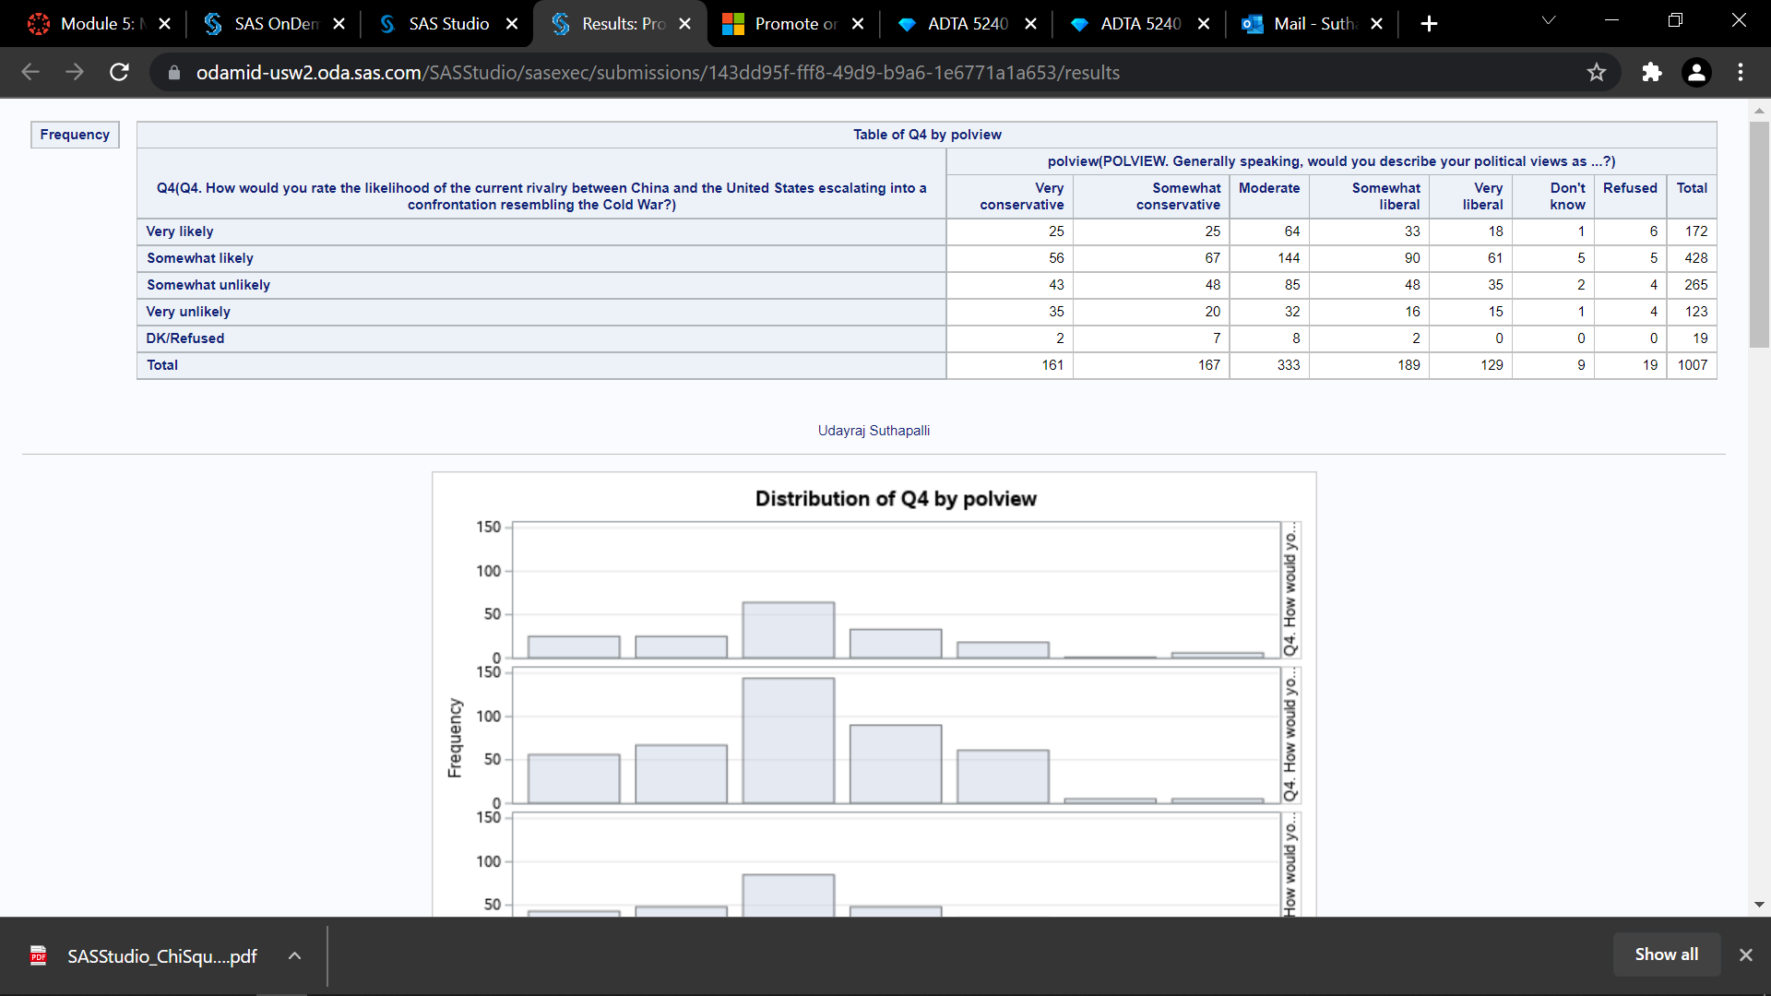

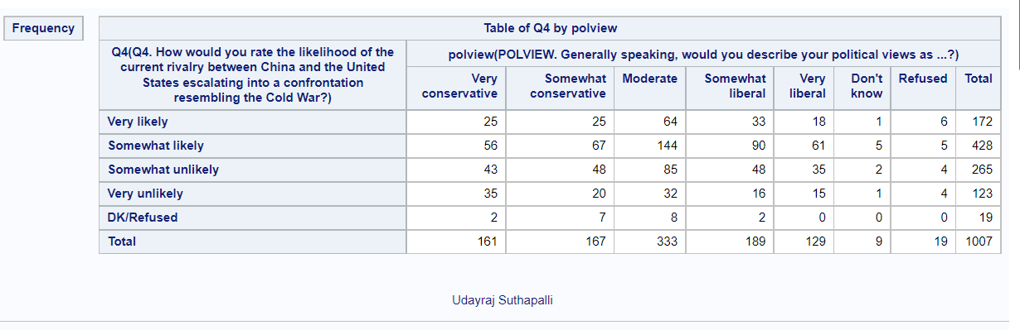

1. Use Graph Tasks to create **Vertical Stacked Bar Chart** of Recodedpolview (Category) and RecodedQ4(Subcategory) in the PEWFILTER2 (You created this data following the instructions of Chi-square in SAS).

**5/5**

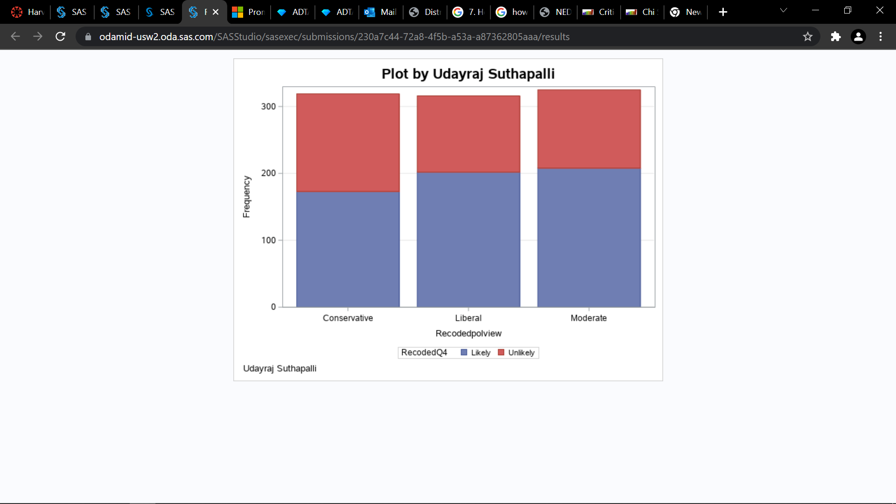

1. Prepare a contingency table showing both of observed and expected frequencies of Recodedpolview (columns) by RecodedQ4 (rows) using the data PEWFILTER2 (You created this data following the instructions of Chi-square in SAS)**.**

**5/5**

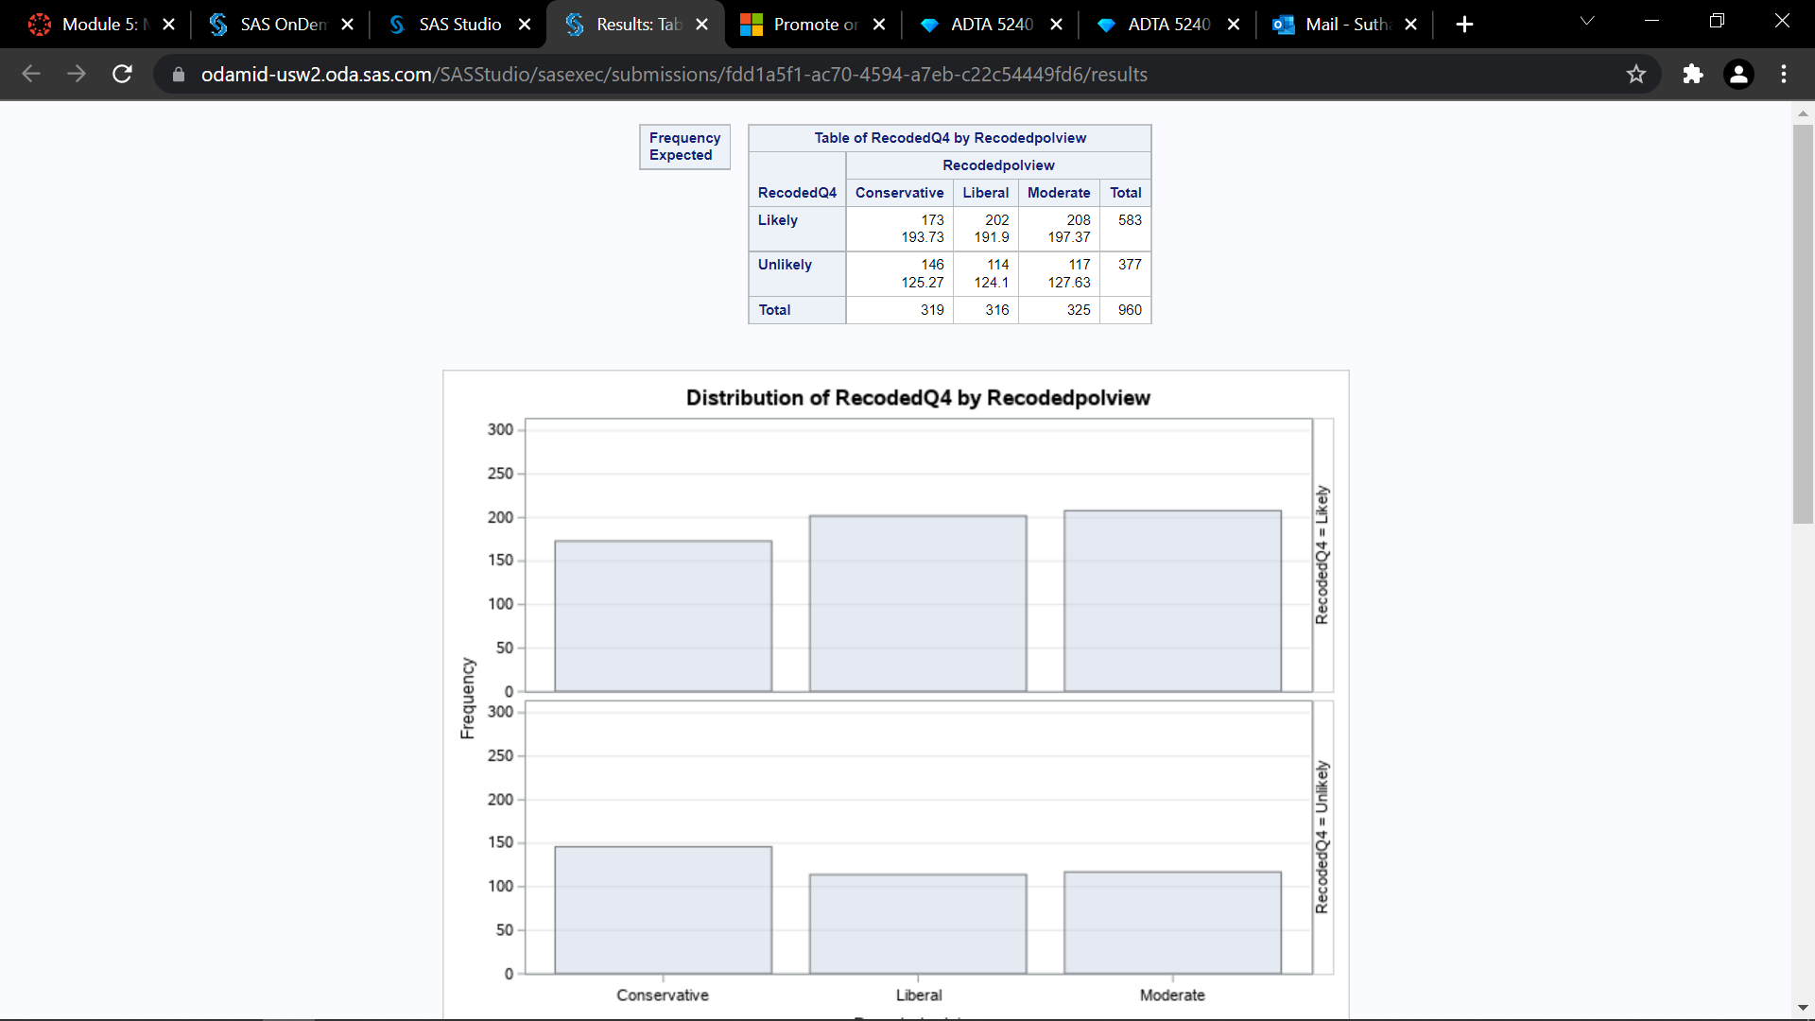

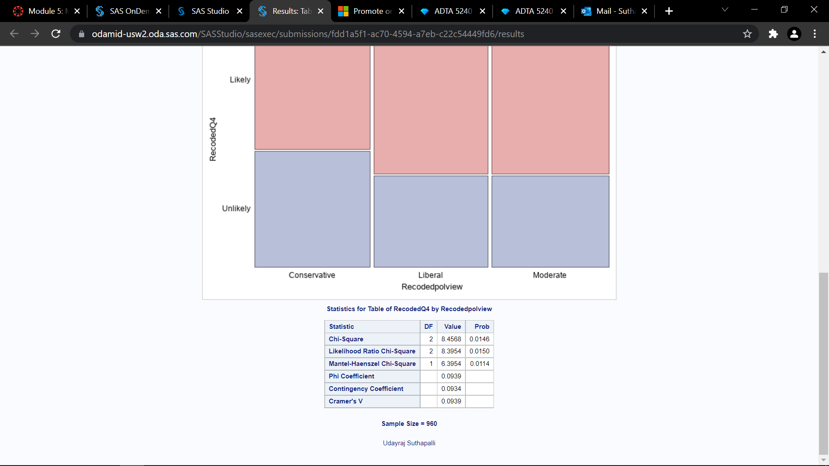

1. State the null hypothesis and alternate hypothesis for this analysis.

5/5 points

Null – H0 = There is relationship between the people’s preference to say political views to the people view on rivalry between US and china confronting to the cold war between them.

Alternate – HA = There is no relationship between the people’s preference to say political views to the people view on rivalry between US and china confronting to the cold war between them.

1. Perform a Chi-Square test to answer the research question. Provide a screen shot of the table that contains the test results. **Please make sure to include your name in the footer for this question. Failure to complete this will result in no credit.**

5/5 points

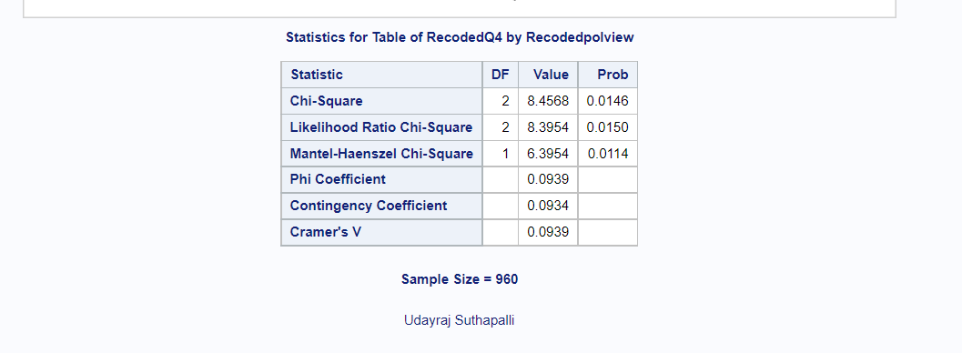

1. What is the critical χ2 value for this problem at the 0.05 significance level (you can use a Chi-square table or the Chi-square Distribution in <https://gallery.shinyapps.io/dist_calc/>)?

5/5 points

Degree of freedom for chi square is 2 , and critical value for χ2 in table Chi-square is 5.9914

1. How do we decide the significance using the critical value or p value?

5/5 points

We can decide the significance using the Critical value. The significance for the critical value 5.9914 is 0.05.

1. Based on the results do you reject or fail to reject the null hypothesis and how?

5/5 points

We reject the null hypothesis if our chi-square calculated value (8.4568) is greater than the critical chi square value (5.9914). And fail to reject if its calculated value is less than critical value.

Here in our case we can reject our null hypothesis as the calculated chi-square value is greater than critical chi square we got.

1. In one sentence, interpret the findings (i.e., Do you find a relationship between people’s political views and their views about the likelihood of current rivalry between China and the US turning into a confrontation resembling the Cold War?)

5/5

From the above question we rejected the null hypothesis, which means there is no good relationship between people’s political view and their view about the war between china and the us turning to cold war. People preference on the political views has no impact on the war between china and US

1. Provide an interpretation of the Cramer’s V (strong, weak or no relationship) on the two variables.

5/5

There is very weak relationship between the political views and the likelihood of rivalry between US and china confronting to the cold war between them.